Question 9

You configured VLANs 10 and 20 on your switch and assigned ports to each VLAN. However, devices in VLAN 10 cannot communicate with devices in VLAN 20. Troubleshoot the issue.

Approach

Since switch is a layer wo device it doesnot support interlan communication. We have to make it with three layer switch or with switch and router. We are going with three layer switch

Make the below connection and assign ip address.

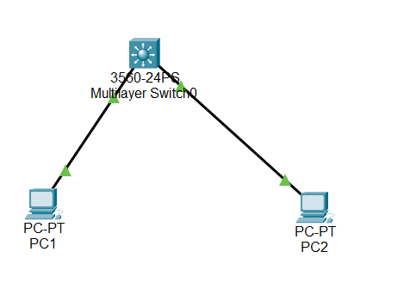

After the connection if you try to ping another device it is impossible.

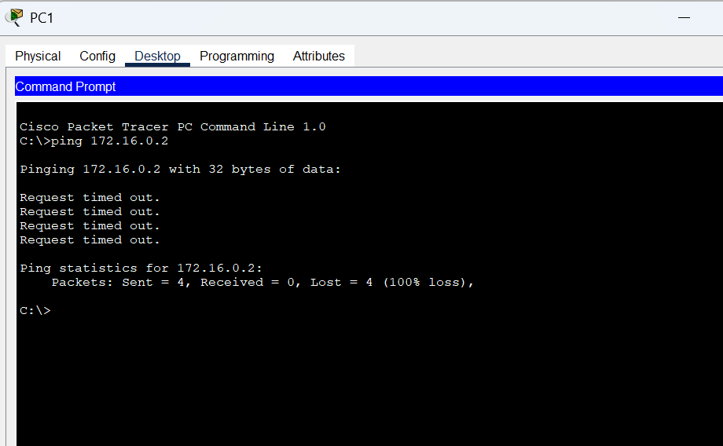

Now we will create tw vlan and assign ip address for it. We are also going to make the switch port mode to access respective vlan. Finally we are going to route the ip

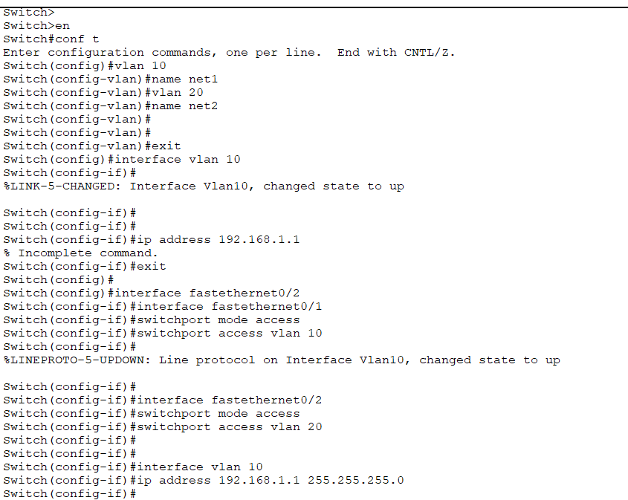

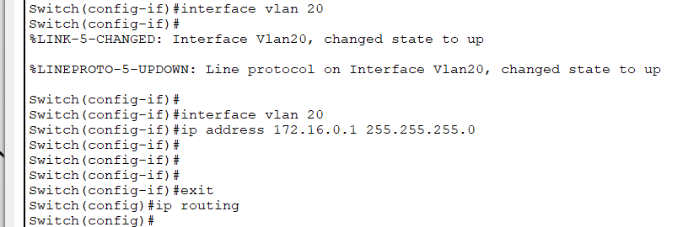

If you see now, the ping is successful

